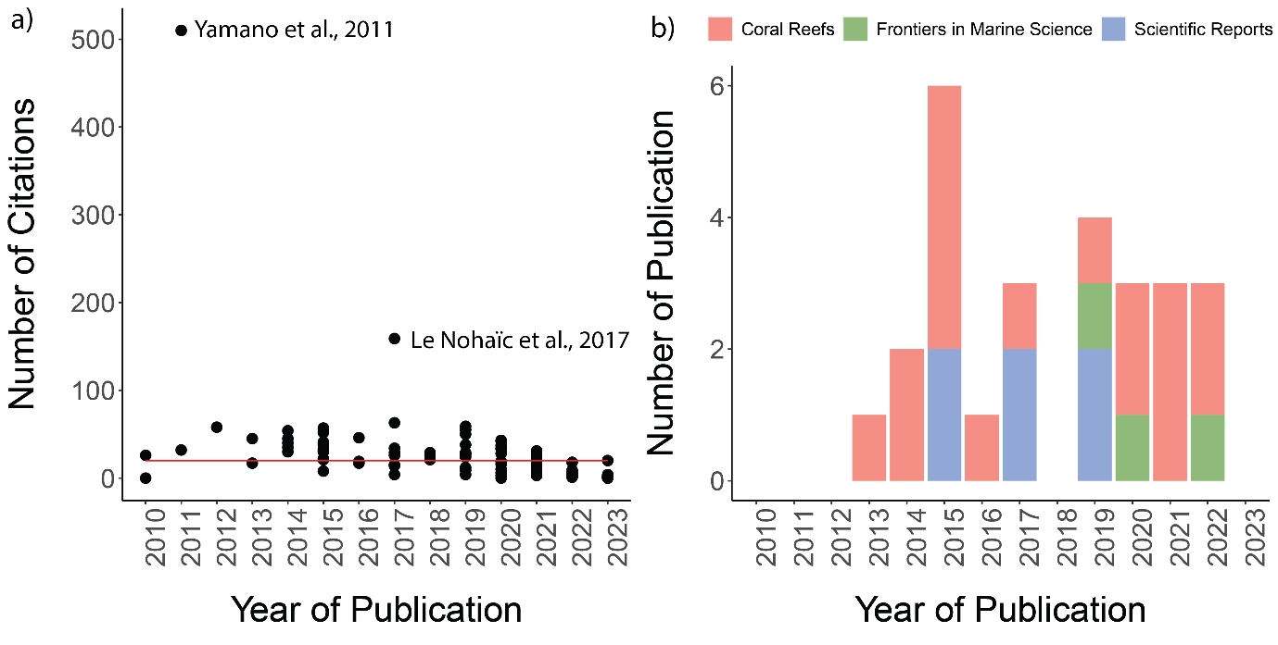

Figure 4a) Number of citations of literature by years. Red line is the median of number of citations across the literature included in this systematic map. b) The top 3 journals by number of publications by year. Created using R package ggplot2.